Star Schema:

In this schema, multiple dimension tables are connected to one fact table.

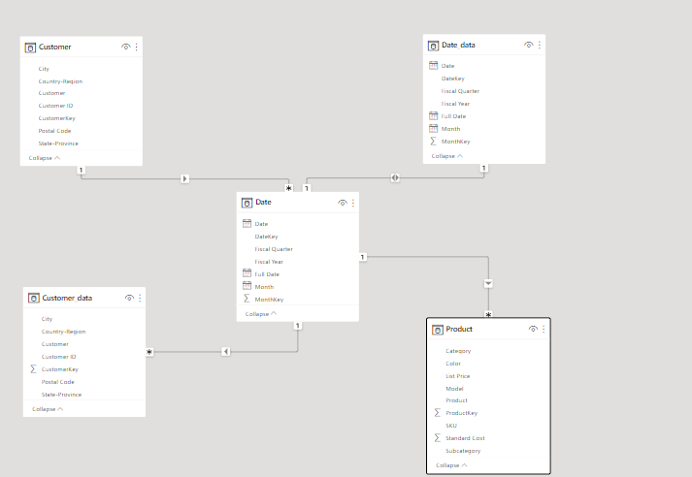

Snowflake Schema:

In this schema, fact table is connected with multiple dimension tables and those dimension tables have sub dimension tables.

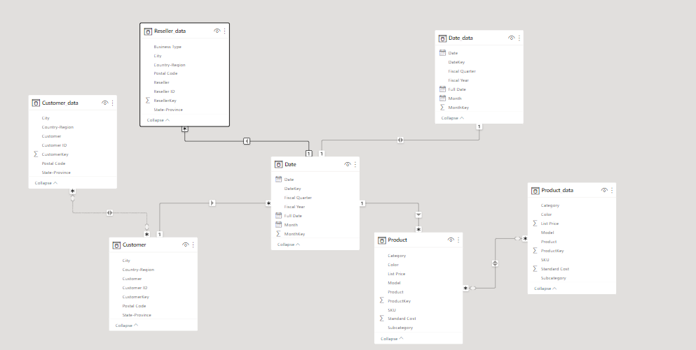

Galaxy Schema:

In this schema, there are multiple fact tables and those have connections with multiple dimension tables.

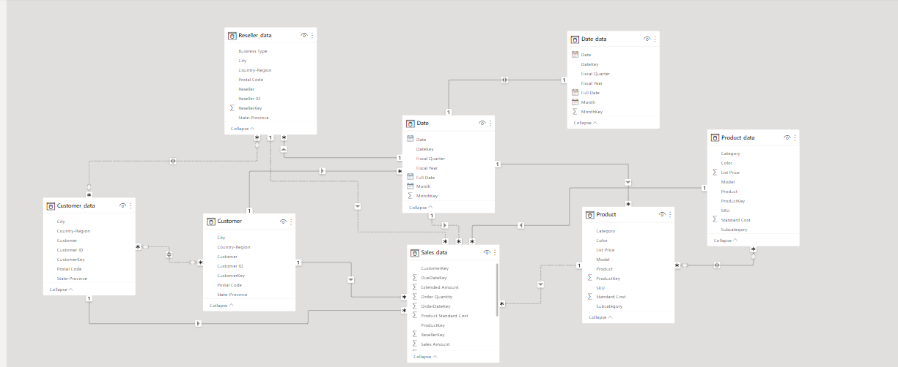

Filter/Slicer:

1. 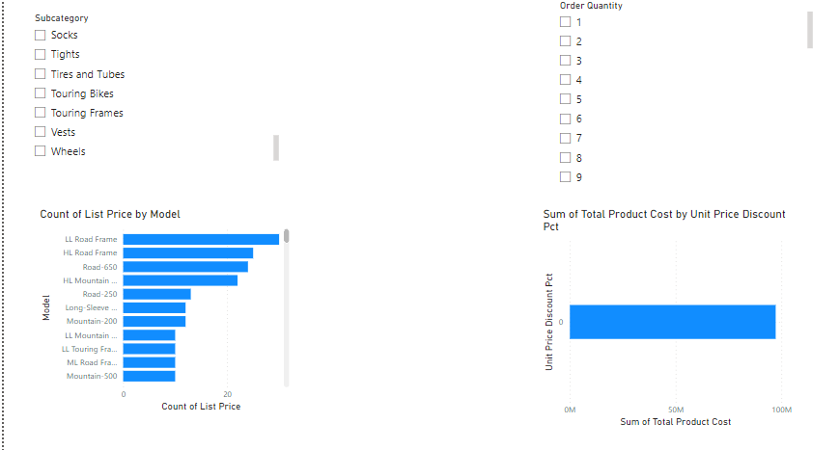Clearing all filters
2. Applying filter in product table

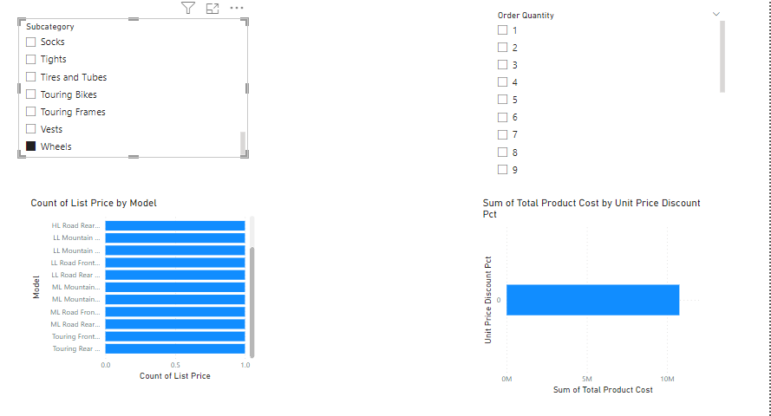

1. Applying filter in product table

